# *THE INTERNATIONAL JOURNAL OF SCIENCE & TECHNOLEDGE*

To,

The Editor-In-Chief

The International Journal Of Science & Technoledge

India

**Subject:** Copyright warranty and authorization form

**Declaration:**

I/We Aniket Wani, Krutika Thakur, Nikhil Vaze, Meeta Vadhel, Rupali Advirkar the author/authors of the paper titled ‘RFID based Intelligent Trolley System using Zigbee’ authorize you to publish the above mentioned article in ‘THE INTERNATIONAL JOURNAL OF SCIENCE & TECHNOLEDGE’.

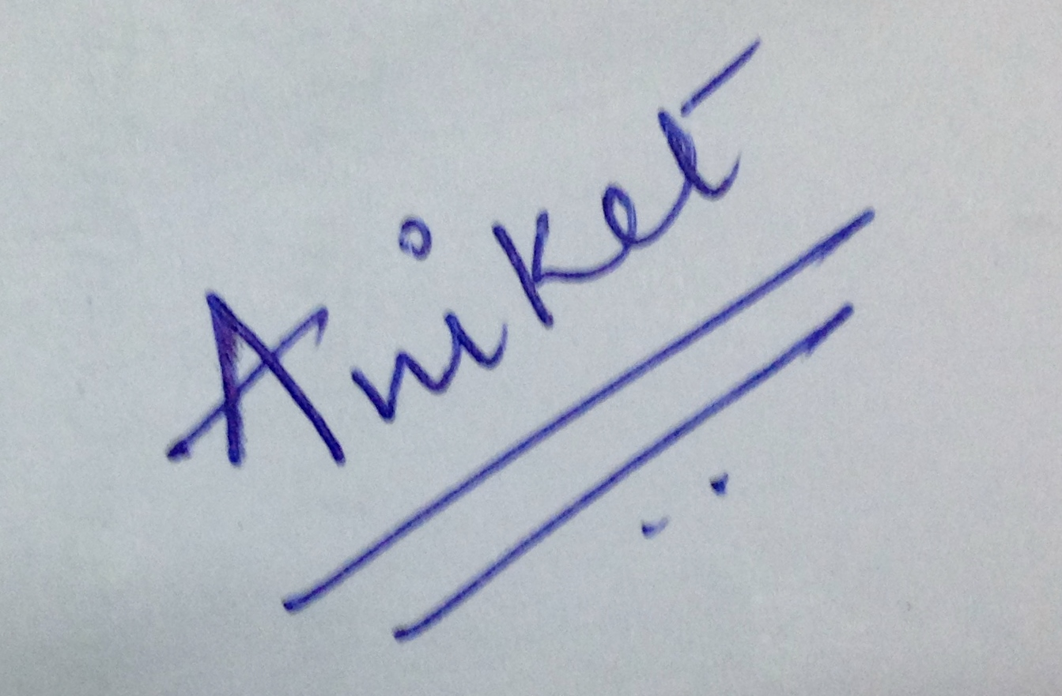

Signature :

Place: Mumbai

Date:28/03/2015

**I/We hereby warrant and declare that:**

1. This article authored by me/us is an original and a genuine research work. It does not infringe on the right of others and does not contain any libelous or unlawful statements. It has not neither been submitted for publication nor published elsewhere in any print/electronic form.
2. I/We have taken permission from the copyright holder to reproduce the matter not owned by me and acknowledged the source.
3. I/We permit editors to publish the said paper in the journal or in any other means with editorial modification, if any.
4. I/We assign all the copyright of this article to the journal, and have not assigned any kind of rights for its publication to any other publisher(s).
5. I/We agree to indemnify the Editors, ‘THE INTERNATIONAL JOURNAL OF SCIENCE & TECHNOLEDGE’ against all claims and expenses arising from any breach of warranty on my/our behalf in this agreement.
6. In case of a paper with multi-authored article, I/corresponding author has obtained permission to enter into an agreement and assign copyright from all the co-authors, in writing and all the co-authors have thoroughly read and agreed with above warranties and authorization.
7. In case of publication of the article in the journal, I/We hereby assign copyright to the ‘THE INTERNATIONAL JOURNAL OF SCIENCE & TECHNOLEDGE’ for its publication in any form/language including all media (print and electronic, or presently unknown), and exclusive right to use the matter for the life of the work (no time restriction on reuse of matter). ‘THE INTERNATIONAL JOURNAL OF SCIENCE & TECHNOLEDGE’ may assign its rights under this Agreement.
8. All disputes subject to jurisdiction of Chhattisgarh High Court, India only

______________________________________________________________________

**Kindly provide the details:**

1. Name: Aniket Wani1, Kruthika Thakur2, Nikhil Vaze3, Meeta Vadhel4, Rupali Advirkar5.
2. Designation: 1,2,3,4Student, 5Professor
3. Institution: 1,2.3,4,5K.J.Somaiya Institute of Engineering and Information Technology
4. Office Address:
   1. Phone:
   2. Fax:
5. Permanent Address: 204 Wellington Hiranandani Estate, Patlipada, G.B. Road, Thane, Maharastra. Pin Code-400607.
6. Phone/Mobile No: +91 9870509099
7. E-mail Id: [wani.aniket2505@gmail.com](mailto:wani.aniket2505@gmail.com)
8. Paste your photo :

